Introduction
Alpha Net is a leading cloud and IT services provider based in Bangladesh, with an international presence through offices in Dhaka, Bogura, and the United States. Founded in 2001 by Abu Sufian Haider, the company has built a strong reputation for delivering enterprise-grade hosting, cloud servers, domain registration, email services, SMS gateways, and licensing solutions to over 5,000 clients in more than 60 countries.

Alpha Net operates its own data centers with Tier-4 infrastructure, including high-speed BDIX connectivity, NVMe SSD storage, and 24/7 monitoring systems. These technical capabilities allow the company to maintain high reliability and scalability across its range of services.

Serving a wide array of customers—from government institutions and corporate entities to startups and developers—Alpha Net is dedicated to simplifying and strengthening digital infrastructure in Bangladesh and beyond.

Mission
To empower businesses and individuals by delivering reliable, secure, and innovative cloud and IT solutions that ensure digital growth and continuity.

Vision
To become the most trusted and customer-centric cloud services provider in Bangladesh and a recognized leader in the global IT industry.
Core Services:
Domain Registration & SSL certificates (.com, .bd, etc.)
Web Hosting: Windows (ASP.NET, .NET Core) and Linux (cPanel, BDIX-connected) alpha.net.bd +1 Trustpilot +1
Virtual & Dedicated Servers: Hosted in Tier-3/4 data centers in Bangladesh and the USA Clutch +3 alpha.net.bd +3 GoodFirms +3
Cloud RDP, Email Hosting, PBX/VoIP systems, bulk SMS, Zoom licensing
Web Design & Development (corporate, e-commerce, CMS-based sites)

Organizational Structure:
Employee hierarchy of Alpha Net:
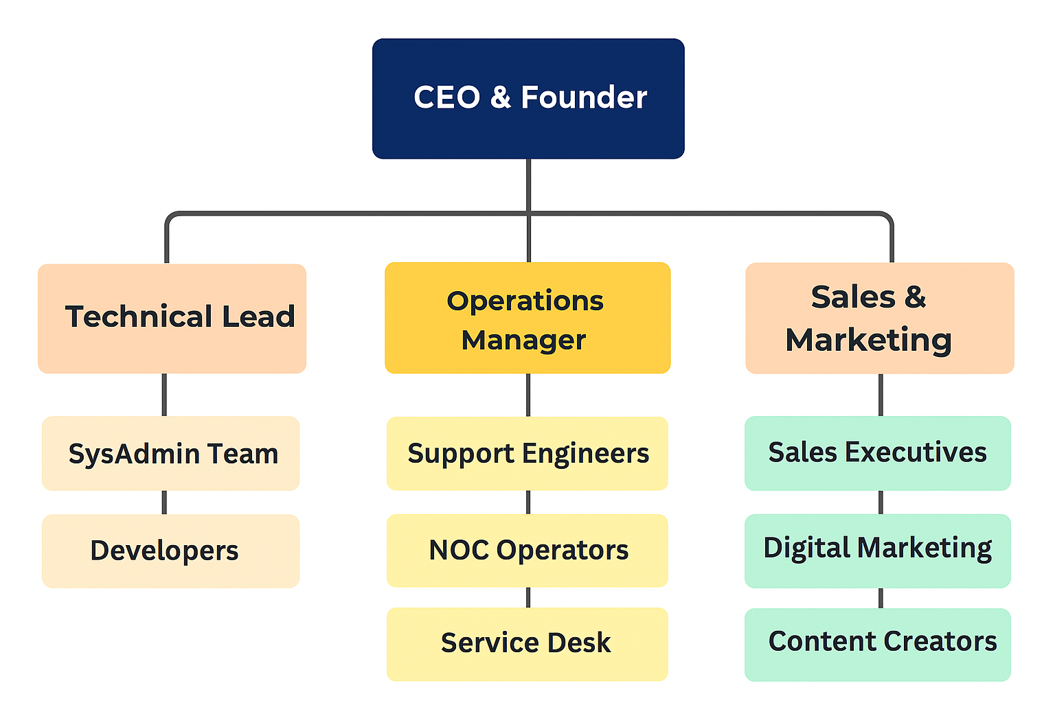
Workflow of Alpha Net:
Key Functional Workflow at Alpha Net
- Sales Initiation
  - Clients approach via website/live chat/social media.
  - Sales team provides consultation & quotes.
- Service Provisioning
  - Technical team configures hosting/domain/email/VPS after order is confirmed.
  - Login credentials and usage guides are sent to clients.
- Ongoing Support
  - Support team handles client issues via ticketing system or direct call.
  - Complex issues are escalated to SysAdmins or Developers.
- Billing and Renewals
  - Automated billing reminders via SMS and email.
  - Finance team oversees payment confirmation and renewals.
- Monitoring & Maintenance
  - Servers are monitored 24/7 using tools like Zabbix and internal dashboards.
  - Security patches, backups, and incident response are handled by NOC.
- Feedback and Optimization
  - Support and Sales teams gather client feedback for improvements.
  - Monthly internal review meetings address performance gaps.
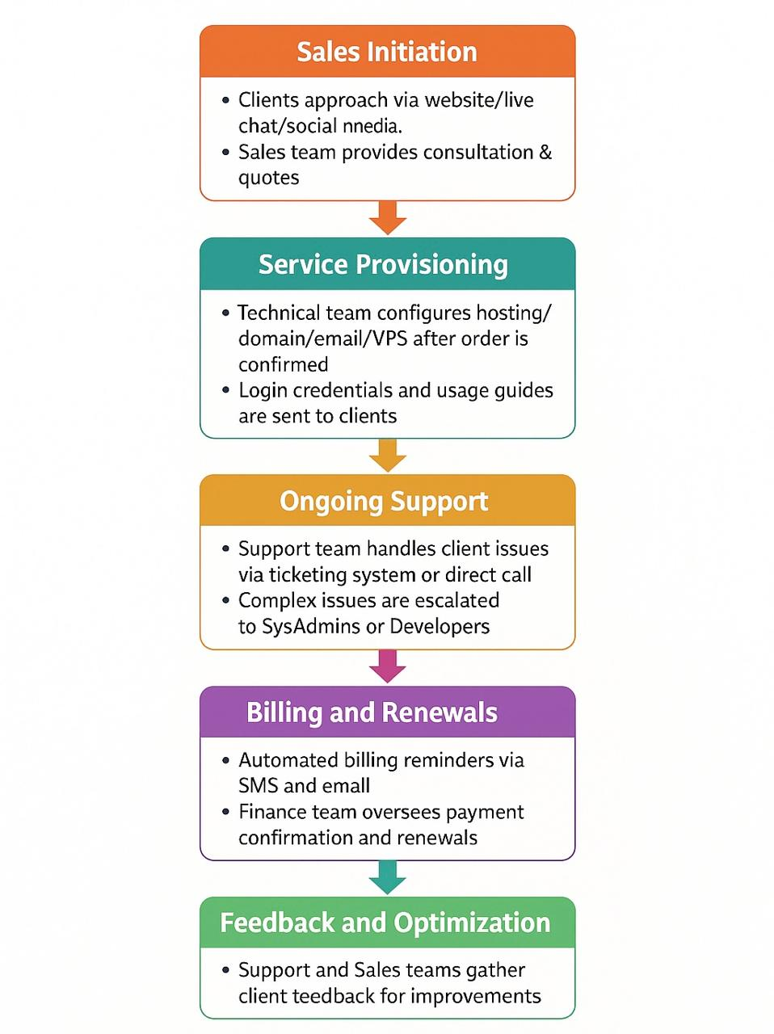

Company Values
- Security First: Proactive infrastructure and client data protection
- Customer-Centricity: Custom solutions based on client knowledge levels
- Innovation: Adoption of new tech like BDIX peering and containerization
- Reliability: 99.99% uptime guarantee via Tier-3 and Tier-4 hosting infrastructure
Problem Identification:

Problem 1: Limited Technical Awareness Among SME Clients Leads to Misaligned Service Adoption
Issue Overview:
A significant portion of Alpha Net’s client base comprises non-technical small to medium enterprises (SMEs). These clients often struggle to understand key distinctions between hosting solutions (e.g., Shared Hosting vs. VPS vs. Dedicated Servers vs. BDIX-optimized plans).
Impact:
- Service packages are frequently under- or over-utilized, leading to performance issues or cost inefficiencies.
- Sales and support resources are overburdened with basic technical education.
- Overall customer satisfaction declines due to service misalignment.
Strategic Risk:
Without streamlined educational onboarding, Alpha Net risks alienating a fast-growing market segment (SMEs) that demand scalable infrastructure but lack in-house IT expertise.
Problem 2: Fragmented Internal Communication Between Cross-Functional Teams
Issue Overview:
There is an observable lack of seamless coordination between the Sales, Technical Support, and Development departments. Key project and client lifecycle stages (e.g., onboarding, customization, issue resolution) suffer from data silos and asynchronous communication.
Impact:
- Sales may over-promise services that current infrastructure or engineering cannot deliver immediately.
- Ticket resolution time increases as support must repeatedly confirm service details from other departments.
- Development updates are not proactively communicated to client-facing teams, resulting in inconsistency and confusion.
Strategic Risk:
Without an integrated communication framework (such as a unified CRM or ticketing system), internal friction may reduce Alpha Net’s operational agility and long-term scalability.
Problem 3: Absence of Intelligent Automation in Customer Support and Infrastructure Monitoring
Issue Overview:
Alpha Net’s current support and monitoring workflows rely heavily on manual processes. No artificial intelligence (AI) or machine learning (ML) systems are deployed for predictive analytics, automated responses, or intelligent recommendations.
Impact:
- First-response resolution time is suboptimal due to human-only ticket triage.
- Monitoring lacks real-time anomaly prediction, increasing the risk of unanticipated downtime or resource exhaustion.
- The website and client portal do not leverage AI to suggest optimal plans or troubleshoot common issues.
Strategic Risk:
Without adopting AI-powered infrastructure and support systems, Alpha Net may fall behind global industry standards, especially in client self-service capabilities and infrastructure resilience.
Problem 4: Overdependence on Upstream Infrastructure Providers Risks Service Continuity
Issue Overview:
Some Alpha Net hosting services rely on master servers leased from third-party upstream vendors. In the event that these vendors default on payments or experience outages, Alpha Net’s end-clients suffer downtime—even if they are in good financial standing.
Impact:
- Service reliability becomes contingent on third-party practices outside Alpha Net’s control.
- Legal and operational accountability becomes blurred in the eyes of clients.
- High-value clients risk reputational and financial loss, potentially resulting in attrition.
Strategic Risk:
Without building autonomous infrastructure and direct control over IP ranges, Alpha Net exposes itself to third-party dependency risks that could hinder SLAs (Service Level Agreements) and enterprise trust.

